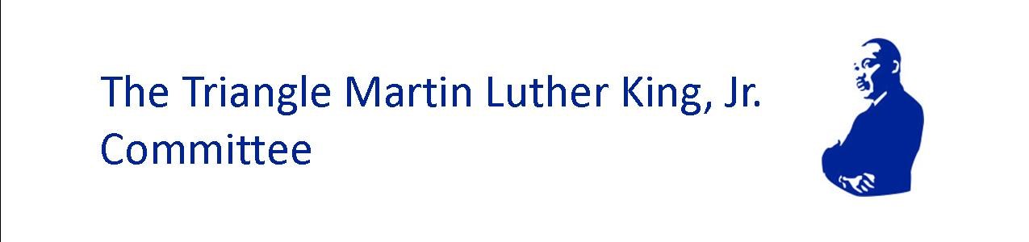

2026 KING LEADER AWARD
Mission Possible II: Steadfast in the Storm: Honoring the Dream Amid Shifting Paradigms

Application Announcement
Due Date: January 6, 2026
The Triangle Martin Luther King, Jr. Committee (TMLKC) seeks applicants for the annual King Leader Award, which recognizes and supports leaders in our community whose work exemplifies Dr. King’s commitment to transformation and justice. The award includes a $7,500 stipend and networking support.
Criteria for the award include:
- Founding and/or leadership of a group, organization or movement making a positive impact on the community in the areas of social justice, transformative relationship building, community empowerment, equity and/or inclusivity.
- A minimum of 3 years working in your identified area of impact (exceptions may be considered for exemplary impact from a start-up entity).
- Location in the greater Triangle and surrounding areas (e.g. Chatham, Durham, Franklin, Granville, Johnston, Orange, Vance and Wake counties) and/or having an impact on these geographic areas
Application Process
- In 500 words, describe your work you and how it reflects the vision of Dr. King’s Beloved Community and our 2026 theme Mission Possible II: Steadfast in the Storm: Honoring the Dream Amid Shifting Paradigms
- Please submit text no smaller than 12-point font.

- Nominations must include a cover page that states:
  - Name of the leader
  - Organization name and a BRIEF synopsis of the mission and work of the organization
  - Link to the organization’s website and/or social media presence
  - Names and contact information of 3 references for the organization’s work and impact
  - 990 or equivalent overview of organization’s activities, governance and detailed financial information MUST be provided in order to be considered.
- Optional: We welcome any documentation of your work — photographs, videos and/or links to news coverage, articles, websites, social media, etc. The Committee recognizes that all applicants may not have the same access to resources and therefore some may not have documentation to share. Documentation will be useful but is not a necessity for full consideration.
Application Submission & Deadline:
- Self-nomination and nomination of others will be accepted.
- Submissions should be made to: planner4trianglemlk@gmail.com Subject Line: KLA Application.
- Completed applications must be received no LATER THAN January 6, 2026, for consideration.
- All monetary awards will be made to the King Leader’s and other finalists’ organizations.
- Finalists will be notified by January 13, 2026, with the winner announced at the annual Triangle MLK, Jr. Interfaith Prayer Breakfast event on January 19th. All finalists must commit to the following:
  - Be in-person at the Triangle MLK Interfaith Prayer Breakfast on January 19th
  - Allow name, image, application essay and organization information to be used at will, without compensation, by TMLKC on our website, social media, newsletters and other media.
About Triangle Martin Luther King, Jr. Committee
Mission
TMLKC is a 501c3 interfaith group who invests in and amplifies the voices of leaders, organizations and movements pursuing systemic and transformational change through collective community service in the Triangle region.

Vision
A world that reflects the Beloved Community where all people are valued, respected and treated with dignity. (Adopted from The King Center’s vision statement)

