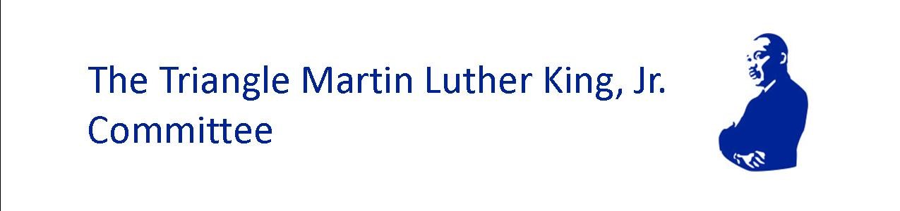

JOHN LEWIS 2025 STUDENT ACTIVIST AWARD
Mission Possible II: Steadfast in the Storm: Honoring the Dream Amid Shifting Paradigms

Application Announcement
Due Date: January 6, 2026

The Triangle Martin Luther King, Jr. Committee (TMLKC) is excited to announce our annual award honoring the life and legacy of the late U.S. Congressman and Civil Rights leader, John Lewis.
Congressman Lewis’ commitment to social justice and transformational change was ignited in his young adulthood and continued as a lifelong pursuit. He called this work “Good Trouble” and throughout his life, urged young people to take up the cause of furthering civil rights for all Americans. TMLKC established this award to recognize and uplift the efforts of a modern-day, passionate young leader who is making significant strides and impact in social justice activism.

Eligibility for the Award:
- Leader between the ages of 14-22 years old (high school or older) who is making a positive impact through social justice activism in the Triangle and surrounding areas (i.e. Chatham, Durham, Franklin, Granville, Johnston, Orange, Vance and Wake counties)

This special recognition award includes:
- $500 honorarium
- Opportunity for engagement with the Committee through future activities, publications, relationship building, etc.
- Help connect recipient with other community leaders for networking.

Application Process
- In 500 words or less, share the story of your journey into social justice leadership:
  - Please submit text no smaller than 12-point font.
  - Describe your work and what you hope to accomplish through your efforts.
  - How does Congressman Lewis’ message of getting into “good trouble” resonate and how is it reflected in the work you have done/are doing?
  - In what geographic area of the Triangle and surrounding communities has your work had impact?
  - Share your current age and school (if applicable) and/or any other affiliations that you would like us to know about.
  - Include at least one letter of reference from an established community leader that attests to the work that he/she has witnessed from you, your impact and the qualities that make you a strong candidate for the award. The letter should include the recommender’s title and organization, relationship to the applicant and how long the recommender has known the applicant. Examples of established community leaders include an official representative from school, church, community organization, etc. Your reference should not be a relative.
- Optional: Please include any documentation of your work in the form of photographs, videos and/or links to news coverage, articles, websites, social media, etc. The Committee recognizes that all applicants may not have the same access to resources and therefore some may not have documentation to share. Documentation will be useful but is not a necessity for full consideration.

Application Submission & Deadline:
- Completed applications including letter of reference must be received NO LATER THAN January 6, 2026.
- Submissions should be made to: planner4trianglemlk@gmail.com. Subject Line: JLA Application.
- Completed applications must be received no LATER THAN January 6, 2026, for consideration.
- Finalists will be notified by January 13, 2026, with the winner announced at the annual Triangle MLK, Jr. Interfaith Prayer Breakfast event on January 19th. All finalists must commit to the following:
  - Be in-person at the Triangle MLK Interfaith Prayer Breakfast on January 19th
  - Allow name, image, application essay and organization information to be used at will, without compensation, by TMLKC on our website, social media, newsletters and other media.

About Triangle Martin Luther King, Jr. Committee
Mission
TMLKC is a 501c3 interfaith group who invests in and amplifies the voices of leaders, organizations and movements pursuing systemic and transformational change through collective community service in the Triangle region.

Vision
A world that reflects the Beloved Community where all people are valued, respected and treated with dignity. (Adopted from The King Center’s vision statement)

